Manual Steps to reschedule request
Once we get email from Rackspace after Terex - PTRXI and PTRXC Maintenance Window.
Copy all failed requests in Notepad.
Check each request in below provided query whether request is Error, Terminated, Cancelled, Normal or Paused Running.
- If the request is Error, Terminated or Cancelled then reschedule the request.
- If request is Normal, then no need to reschedule.
- If the request is Paused Running, then ask Rackspace to cancel and you reschedule.
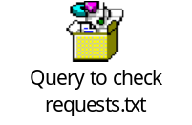
Once validated from your side ask Rackspace to share zoom link to reschedule program.

Follow the steps provided in the documents.
- Steps to reschedule normal programs
- Steps to reschedule pick release programs

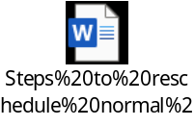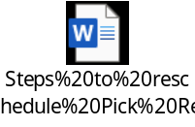
Reconfirm the request in backend and send email to TMSNotification group.
If any request failed to reschedule, please check with the team before sending any email.

